GLOBAL RISK INTELLIGENCE QUERY DOCUMENT
- SUMMARY
SECTION 1: Tables
1. View the first 15 rows of the Geography Dimension
SELECT TOP 15 * FROM dim_countries;
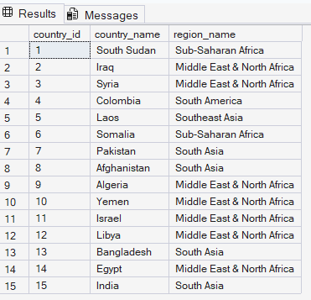
2. View the AI-generated Threat Categories
SELECT * FROM dim_categories;
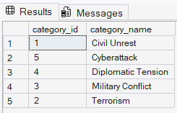
3. View the first 10 rows of the Fact Table
SELECT TOP 10 * FROM fact_events;
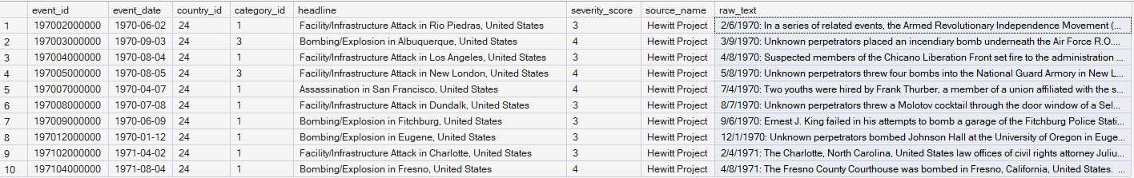

Section 2: Validation & Quality Control
4.Total fact records
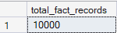

5.Audit for orphan records and missing critical dates
SELECT
SUM(CASE WHEN country_id IS NULL THEN 1 ELSE 0 END) AS null_countries,
SUM(CASE WHEN category_id IS NULL THEN 1 ELSE 0 END) AS null_categories,
SUM(CASE WHEN event_date IS NULL THEN 1 ELSE 0 END) AS null_dates
FROM fact_events;
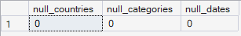

6.Reconstruct the schema to show the volume and severity per category
SELECT
c.category_name,
COUNT(f.event_id) AS total_incidents,
ROUND(AVG(CAST(f.severity_score AS FLOAT)), 2) AS average_severity
FROM fact_events f
INNER JOIN dim_categories c ON f.category_id = c.category_id
GROUP BY c.category_name
ORDER BY total_incidents DESC;
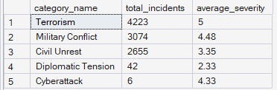

7. View 1: Aggregated Monthly Trends for Power BI
CREATE OR ALTER VIEW vw_Monthly_Trends AS
SELECT
YEAR(f.event_date) AS Event_Year,
MONTH(f.event_date) AS Event_Month,
c.category_name,
COUNT(f.event_id) AS Total_Events
FROM fact_events f
INNER JOIN dim_categories c ON f.category_id = c.category_id
GROUP BY
YEAR(f.event_date),
MONTH(f.event_date),
c.category_name;
GO
SELECT TOP 10 * FROM vw_Monthly_Trends;
I used an INNER JOIN to connect the facts to the category dimension, then used a GROUP BY to aggregate the total events per month. This is the exact view I used to feed the trend-line visual in my Power BI dashboard.

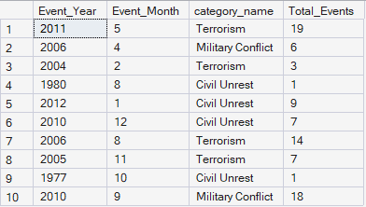

8. View 2: Top 5 Highest Risk Countries
CREATE OR ALTER VIEW vw_Top_5_Countries AS
SELECT TOP 5
c.country_name,
COUNT(f.event_id) AS Total_Events,
AVG(f.severity_score) AS Average_Severity
FROM fact_events f
INNER JOIN dim_countries c ON f.country_id = c.country_id
GROUP BY
c.country_name
ORDER BY
Total_Events DESC;
GO
SELECT * FROM vw_Top_5_Countries;
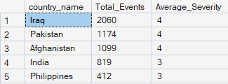
To optimize dashboard performance, instead of letting Power BI calculate the top countries, I pushed the computation to the SQL backend using a GROUP BY and an ORDER BY DESC clause with a TOP 5 limiter.

9. View 3 : Window Function isolating the maximum severity event per country
CREATE OR ALTER VIEW vw_Worst_Event_Per_Country AS
WITH RankedEvents AS (
SELECT
c.country_name,
f.event_date,
f.headline,
f.severity_score,
ROW_NUMBER() OVER (PARTITION BY c.country_name ORDER BY f.severity_score DESC) as Rank_Number
FROM fact_events f
INNER JOIN dim_countries c ON f.country_id = c.country_id
)
SELECT
country_name,
event_date,
headline,
severity_score
FROM RankedEvents
WHERE Rank_Number = 1;
GO
SELECT TOP 10 * FROM vw_Worst_Event_Per_Country;
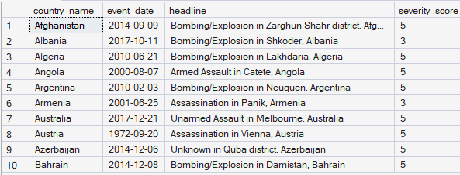
I used a CTE combined with the ROW_NUMBER() window function. By partitioning the data by country and ordering by severity descending, I was able to assign a rank of '1' to the worst event in every country, and then filter the final output to only show those maximum severity events.

10.View 4 : Stored Procedure: Parameterized execution for Severity 5 events
CREATE OR ALTER PROCEDURE sp_GetCriticalEvents
@MinSeverity INT
AS
BEGIN
SELECT
event_date,
headline,
severity_score
FROM fact_events
WHERE severity_score >= @MinSeverity
ORDER BY event_date DESC;
END;
GO
EXEC sp_GetCriticalEvents @MinSeverity = 5;
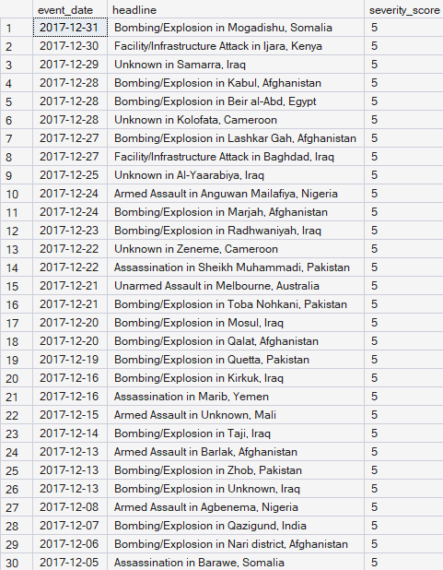
I wrote a parameterized stored procedure. This allows end-users or reporting applications to dynamically pass in a threshold, like a severity score of 4 or 5, and immediately retrieve the filtered dataset without needing to know how to write SQL.

